Student Management

Update Transaction

Version <1.0>

Revision History

|  |  |  |  |
| --- | --- | --- | --- |
| **Date** | **Version** | **Description** | **Author** |
| <dd/mmm/yy> | <x.x> | <details> | Đào Anh Thành |
|  |  |  |  |
|  |  |  |  |
|  |  |  |  |

Table of Contents

1. Update transaction 3

1.1 Brief Description 3

2. Flow of Events 3

2.1 Basic Flow 3

2.2 Alternative Flows 3

2.2.1 < First Alternative Flow > 3

2.2.2 < Second Alternative Flow > 3

3. Special Requirements 3

3.1 < First Special Requirement > 3

4. Preconditions 3

4.1 < Precondition One > 3

5. Postconditions 3

5.1 < Postcondition One > 3

6. Extension Points 3

6.1 <Name of Extension Point> 3

# Update transaction

## Brief Description

This use case defines steps of updating student’s transaction using system. Accountant can know who did not complete paying fee.

## Actor

Accountant

# Flow of Events

The accountant selects “transaction” button to import an excel file. System will import that file then display students who haven’t paid fee yet.

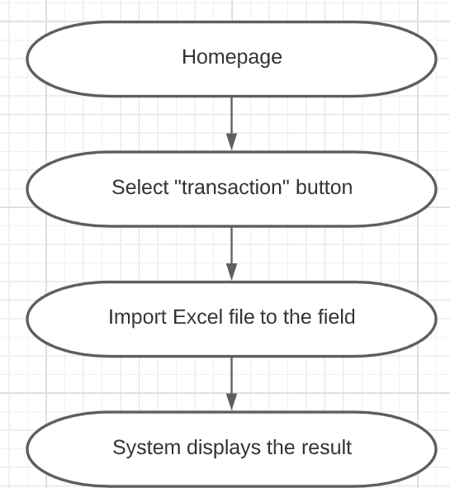

# Special Requirements

The system accepts Excel format only

# Preconditions

User signs in as accountant

# Postconditions

No postconditions

# Extension Points

No extension points